GUJARAT TECHNOLOGICAL UNIVERSITY
Chandkheda, Ahmedabad


G. H. PATEL COLLEGE OF ENGINEERING AND TECHNOLOGY
Department of Computer Engineering

“Project Birdie”
A Project Report Submitted to
Gujarat Technological University in Fulfillment of the Requirement of the
Degree of Bachelors of Engineering In
Computer Engineering

2180706: Project II

B. E., Semester – VIII
By
Group ID: 87836
Academic Year 2019-20

Sr. No. | Name | Enrollment No.
1 | Patel Malav Prashant | 160110107040
2 | Patel Shrey Rakeshbhai | 160110107045

Faculty Guide
Prof. Israni Priyanka
[Assistant Professor (CP)]

ACKNOWLEDGEMENT

We would like to express our gratitude and appreciation to all those who gave us the incentive to work on this project. A special thanks to our project guide, Prof. Israni Priyanka, whose presence, stimulating suggestion and encouragement, helped us to coordinate our project.

Hereby, we would like to acknowledge with the much reverence the crucial role of our department, who are supportive and provided us with all possible assistance as and when required.

Moreover, we are thankful to the Head Of Department (Computer), Dr. Patel Maulika, who has given her unmatched guidance in achieving the goal as well as her motivation to maintain our project’s progress in track. Last but not the least, the involvement of the panels during every single presentation helped us vivify our vision for this project, their straight forwardness and concise aided our ambition in making of this project.

COLLEGE CERTIFICATE

Date: 05/06/2020


This is to certify that the project entitled “Project Birdie” has been carried out by Patel Malav (160110107040) and Patel Shrey (160110107045) under my guidance in partial fulfillment for the degree of Bachelor of Engineering in Computer Engineering (7th Semester) of Gujarat Technological University, Ahmedabad during the academic year 2019-20.

Internal Guide Head of Department
Prof. Israni Priyanka Dr. Patel Maulika

Undertaking of Originality of Work

We hereby certify that we are the sole authors of this UDP project report and that neither any part of this UDP project nor the whole of the UDP project report has been submitted for a degree by other student(s) to any other University or Institution

We certify that, to the best of our knowledge, the current UDP project report does not infringe upon anyone’s copyright nor violate any proprietary rights and that any ideas, techniques, quotations or any other material from the work of other people included in our UDP project report, published or otherwise, are full acknowledged in accordance with the standard referencing practices. Furthermore, to extent that we have included copyrighted material that surpasses the boundary of fair dealing within the meaning of the Indian Copyright (Amendment) Act 2012, we certify that we have obtained a written permission from the copyright owner(s) to include such materials in the current UDP project report and have included copies of such copyright clearances to our appendix

We declare that this is a true copy of our report, including any final revisions, as approved by our supervisors.

Date: /06/2020

Place: Vallabh Vidyanagar, Anand
Enrollment No. | Name | Signature
160110107039 | Patel Malav Prashant
160110107045 | Patel Shrey Rakeshbai

ABSTRACT

Researcher’s have found that there is an unprecedented decrease in aviation life due use of some modern technologies that make human life comfortable, this is a real world problem that we are facing, similar global warming but there is more awareness for it due to children being educated to it by various means in schools and other various sources like news channels, papers & articles for adults.

The problem with awareness in this issue it is less known to people due to not being covered by traditional sources like schools and news channels, but there are news and articles about it and platform to educated the children about life of birds as well as adults but they are not that interesting as they should be, if they were then problem would have been known and aware to more number of people.

To answer that issue this “Project Birdie” is trying to solve by making an innovative & non traditional standard application where the users will be educated to birds and their amazing life and contribution to world as well as bring interest to people, thus making them involved in some activity that is unique which will help further this project as well as people who will understand the problem we said above, as they are involved in it they will tend to make efforts to reduce the problem and educate people about it.

“Project Birdie” is a web application that will be an interactive and attractive platform for educating people about the birds and provide insights to them and start people in engaging in the activity that can be used to benefit environment as well as users.

INDEX

Chapter No. | Titles | Page No.
1. Introduction |  | 1
1.1 | Project Introduction | 1
1.2 | Traits and Characteristics | 2
1.3 | Scope and Purpose | 3
1.4 | Literature Survey | 4
1.5 | Work Plan | 9
1.6 | Project Methodology | 10
2. Design Analysis & Methodology, Implementation Strategy |  | 11
2.1 | AEIOU Summary Canvas | 11
2.2 | Product Development Canvas | 12
2.3 | Empathy Canvas | 13
2.4 | Ideation Canvas | 14
3. Implementation |  | 15
3.1 | Web Service – API | 15
3.2 | Web Hosting – Staticsite | 17
3.3 | Database Hosting – MongoDB | 18
3.4 | Authentication – Firebase | 18
3.5 | Web App – Project Birdie website | 19
3.6 | Reward System | 22
4. Summary |  | 23
4.1 | Implemetation Results | 23
4.2 | Summary of Result | 28
4.3 | Future Scope | 28
5. References |  | 29
6. Appendix |  | 30
6.1 | Periodic Project Reports | 30
6.2 | Business Modeling Canvas | 33
6.3 | Patent Drafting Exercise | 37
7. Plagiarism Report |  | 43

List of Figures

Figure No. | Figure Name | Page No.
1.1 | Project Plan | 10
2.1 | AEIOU Summary Canvas | 11
2.2 | Empathy Mapping Canvas | 12
2.3 | Ideation Canvas | 13
2.4 | Product Development Canvas | 14
3.1 | GraphQL Architecture | 16
3.2 | VPS Architecture | 17
3.3 | MongoDB Architecture | 18
3.4 | Firebase Architecture | 19
3.5 | Angular Architecture | 20
4.1 | Authentication Overview | 23
4.2 | Login Component | 23
4.3 | Register Component | 23
4.4 | Forgot Component | 24
4.5 | Verify Component | 24
4.6 | Email Confirm | 24
4.7 | Explore Overview | 25
4.8 | Aves Component | 26
4.9 | Observations Component | 26
4.10 | Interactive Controls | 27
4.11 | Search Component | 27
4.12 | Account Overview | 27
6.1 | PPR – 1 | 30
6.2 | PPR – 2 | 31
6.3 | PPR – 3 | 31
6.4 | PPR – 4 | 32
6.5 | BMC Canvas | 33

Chapter – 1

Introduction

1.1 – Project Introduction

The real world problem is unprecedented decrease in Aviation life due to development of new technologies befitting human life but harming the nature, less or no awareness of the problem is being educated to humans and they tend to ignore such problems as part of their nature due to the education platform and news platform does not really tend to focus on such problem apart from environmental problems like global warming as they are not well known or no effort is given.

There are news and articles about such platform already present but they are not enough to highlight this problem as people want something attractive and interesting thing to get focus, this does not include the things like wildlife channels and the photographers that do exploring to get insights into wildlife but apart from that there is no other means to educate people, i.e. there are news article and static data representing websites, apps and other mediums but they are not interesting enough for people to get redirected to and use such things and are kinda boring.

To make people educate about the problem our project is trying to solve it by means of an interactive application that represents the data to user while being informative and attractive with making user involved in the activity and keeping their interest and engaging them into some social attraction that will help them get educated about the life of birds as well as getting data from them to improve the platform upon.

1.2 - Traits and Characteristics

To Educate users about the real world problem an article and newsletter does not make it that user is now aware of the problem. The user needs to be educated about birds and their environment to make the user involved so he/she can understand the problem in depth and then educate others.

To achieve an interactive application the user must be able to explore in depth with various visual interfaces and feel that he/she can get from the application getting their interest so that they may actually learn and try to remember information, thus maybe making them involved in activity they want to seek out.

Activity is essential part of the application as it will make user actually involved into the world of birds by making them a watchlist that they could spot at their nearby location and sharing it to others that they spotted some birds unique to their area and making a contribution to the application as well as for themselves and understanding the real world problem more effectively.

The contributions from the users may not be a good research image and data may not be accurate enough to be used in a high level application but it can be used as means for research verification or other applications where we want to see some trends.

To provide data from our application we may have to extract information from the minimal data that user provides to be used for some purposes and output the data from the system to any user that may build upon the application and implement an API to deliver the data.

The API is not only going to be used by others to use data but also on the application front end also, so the API needs to be flexible in getting the required data from the application. Now to bring interest to new users and communities that may help the application grow we intend to provide a method to feature a user with good contribution that is done by him / her on various social media so that more people can engage in the activity.

1.3 - Scope and Purpose

To make an application that is accessible to most widespread audience possible on computing device, i.e phone, laptop, computer, any other device where internet connection is possible with a display device that will educate people about insights into world to birds and bring interest to users in form of engaging activity they can perform, thus making the application into a data collection system to get update from users about nearby birds they may find which can be used for research and insights into the nature of birds.

- Make a web application that works on browsers supporting WebGL.
- The Application needs to be interactive and engaging to users.
- Users can perform activity in the real world and share their activity to application.
- Serve data received from the users and other project that are used in project to be used by other developers in their own projects.
- Method to feature user submitted data from activity to social media handles to bring interest to others.

1.4 - Literature Survey

The idea for the project kickstarted when we tried searching for a bird – on google what we found was google giving us the basic information such as name, scientific name, lifespan, species classification and more fields that can be classified into and standards used, with links to news, images, videos, and sites that are related to animals / birds like national geographic, Wikipedia and articles links, blogging sites, On further going deep into the results we found some websites that does show us details about the animals like ebird.org , birdlife.org and they have various projects and resources that can educate people about the problem but there is a catch they are in form of article and news some of it is in images and videos which are great to watch and accomplishes goal to educate people about the problem but they are all in traditional means.

None of them provided a way that was engaging to use to search and use it for amusement purposes or even make them interesting enough to make them involved in some activity. These organizations also do ground level work on local schools and in areas in forest but it may not reach a wide spread audience.

Now for literature survey we used these website of organization to learn about their work and activity they do to base and understand the needs and requirement for our project.

1. – National Geographic : www.nationalgeographic.com

Undoubtedly this is the first name that comes into any person’s mind when they hear wild animals as its a reputed^{[1]} magazine, channel, website with wildlife photographers, film makers, journalist that covers the animal kingdom and make featured presentation on them which are available in mostly all of the countries in world and their website also may come up as resource when people are searching and children are also looking it up in their speeches in school or any other activity.

What we found on the website was they had their own version of wiki, to give out the same information i.e. images, videos, articles, news which was better in visual appeal than wikipedia but relatively same with no difference in it.

But they had section on website about kids where they can learn about scientific discoveries
- website was visually appealing and had classification of various categories for animals.
- website had some games that childrens can engage into.
- various links that have nice articles extended by various slide shows which are interactive and polls that readers can engage into.
- Videos links to their resources and easy way to explore it.
- Some interesting apps like to get random fact about a topic.
- Some of the books are made free to read.
- Some videos were targeted to get children's attention and made in comic and fun way.

The website provided basic knowledge of all of their areas of interest that they make content on and provide means to read / view it using their website, National Geographic does not have any application native to android, ios, linux, windows or macbook just a website that serves the content to users.

2. – ebird : https://ebird.org

eBird began with a simple idea that every birdwatcher has unique knowledge and experience. Our goal is to gather this information in the form of checklists of birds, archive it, and freely share it to power new data-driven approaches to science, conservation and education. At the same time, we develop tools that make birding more rewarding. From being able to manage lists, photos and audio recordings, to seeing real-time maps of species distribution, to alerts that let you know when species have been seen, we strive to provide the most current and useful information to the birding community.

This Project is a large scale website developed by people working in a Non Profit Organization it is managed by the Cornell Lab of Ornithology and is supported entirely by grants, sponsors, and donations.

The Project Includes various application

• ebird Website.
• ebird Mobile application.
• ebird merlin application for identifying bird by means of image or description about the bird uses advance Image processing and machine learning tools to predict the species.
• NestWatch a mobile application and website to provide research data by taking images of bird nest and submitting its photographs and other data related to it.
• Ictio – application to make a fish watchlist using marine life data

The Project Feature in brief as follow
- Find more birds.
- Keep track of your bird lists, photos, and sounds.
- Explore latest sightings from around the world.
- Join the world’s largest birding community.
- Contribute to science and conservation.
- Species Maps and advance tools to search data.
- A dynamic video generation tool that shows trends of birds of migration, strength and other.
- data in a video form that is generated by setting parameters.
- Account to manage personal data & ways to credit users.
- Data Submission to project by user.
- Watchlist generation for user in locality.
- Explore data by use of bird hotspot zones.
- Photo and sound search for a species.
- Alerts for a rare species to be found in locality.
- Quiz and various articles related to birds.
- Events organized by partner organization like BirdCount India which is India organization.
- that does event like getting a state bird data by crowd sourcing and calling all the users from.
- the various projects to get involved.
- It also publishes journals from the Cornell University and various articles.
- Provides data that can be used by others to do research and develop applications
- Exploring species provides some basic information with images and maps about areas where birds maybe observed

3. – iNaturalist : https://www.inaturalist.org

One of the world’s most popular nature apps, iNaturalist helps you identify the plants and animals around you. Get connected with a community of over 750,000 scientists and naturalists who can help you learn more about nature! What’s more, by recording and sharing your observations, you’ll create research quality data for scientists working to better understand and protect nature. INaturalist is a joint initiative by the California Academy of Sciences and the National Geographic Society.[6]
It’s also a crowdsourced species identification system and an organism occurrence recording tool. You can use it to record your own observations, get help with identifications, collaborate with others to collect this kind of information for a common purpose, or access the observational data collected by iNaturalist users.[6]
iNaturalist is an online social network of people sharing biodiversity information to help each other learn about nature, It is an Open source platform where a person might do anything with the platform contribute to it, use data for its research purpose, share data over it, by means of crowdsourcing and support from organization its a powerful and best of some of projects that are done in the same category.

List of Features include
- Explore Species data submitted by users.
- Account to keep track of user submission & creating purpose.
- Data submission portal to submit the data.
- Community Form for discussion.
- Community Driven Projects that are integrated with the website to classify certain species eg. birds-of-the-world is a classification project where only verified data submitted by users and approved by user is collected which has nearly 4,000,000 submission with 9000+ species and 36,000+ identifiers and 180,000+ observers.
- It provides a Guide to educators on using platforms for education.
- It has collected over various Taxonomic information in languages around the world.
- It has Leaderboards and Ranking for users and featuring them.
- Guides related to various spots for users to travel and see nature around the world.
- Articles provided by the website.

The Platform is an application where in this project we will try to improve upon, the problem here is that the information shown here is only user contributions and data they have used from projects over the years ahead.

The Project has Android & IOS application for the same purpose which are all well designed and the website is also elegant and beautiful, but as shown in the map above we it is 2D map with some level of interactivity but limited to only zooming and seeing areas of contribution and searching via a map, or grid of submission, list.

The Information shown on species page is charts with categories like season, history, life stage organism was spotted & sex, with map of sightings, Wikipedia beautified content, Trends and related articles & Taxonomy Information.

Summary

In Prior Art Search we found various website and application that are related to our project we found an application that follows ideologies of our own but we have to extend upon its base to finish our goal, various resources are wonderful tools for solving real world problems but we still believe that our application is a more interesting approach on all the past projects.

From the Prior Art Search we found that we have to extend our application to support mobile phones so more number of users can engage into the project thus making our choice of framework to be something that we can use over the web, android, ios.

1.5 - Work Plan

Sr. No | Particulars |  | Time [Months]
 | Tasks | Member | 1st | 2nd | 3rd | 4th | 5th | 6th | 7th | 8th | 9th | 10th
Analysis
1 | Find out tools and technologies to be used and datasets to source for the project | Malav Patel  Shrey Patel | ✓ | ✓
2 | Research on the solutions, way to provide insights | Malav Patel |  | ✓ | ✓
3 | Discover various techniques and methods to implement 3d models | Shrey Patel |  | ✓ | ✓
Implementation
1 | Module 1: Authentication & Account | Malav Patel |  |  | ✓ | ✓
2 | Module 2: Explore Component | Shrey Patel |  |  | ✓ | ✓ | ✓ | ✓
3 | Module 3: Backend API | Malav Patel |  |  | ✓ | ✓ |  |  | ✓ | ✓
4 | Module 4: Watch List | Malav Patel |  |  |  |  |  | ✓ | ✓
5 | Module 5: Reward System | Shrey Patel |  |  |  |  |  |  | ✓
Verification & Integration
1 | Collecting and assembling different modules according to work flow | Malav Patel |  |  |  |  |  |  |  | ✓ | ✓ | ✓
2 | Final Integration of Front End with Backend | Shrey Patel |  |  |  |  |  |  | ✓ | ✓ | ✓
3 | Integration of API of social media platforms | Malav Patel |  |  |  |  |  |  |  |  | ✓ | ✓

1.6 - Project Methodology

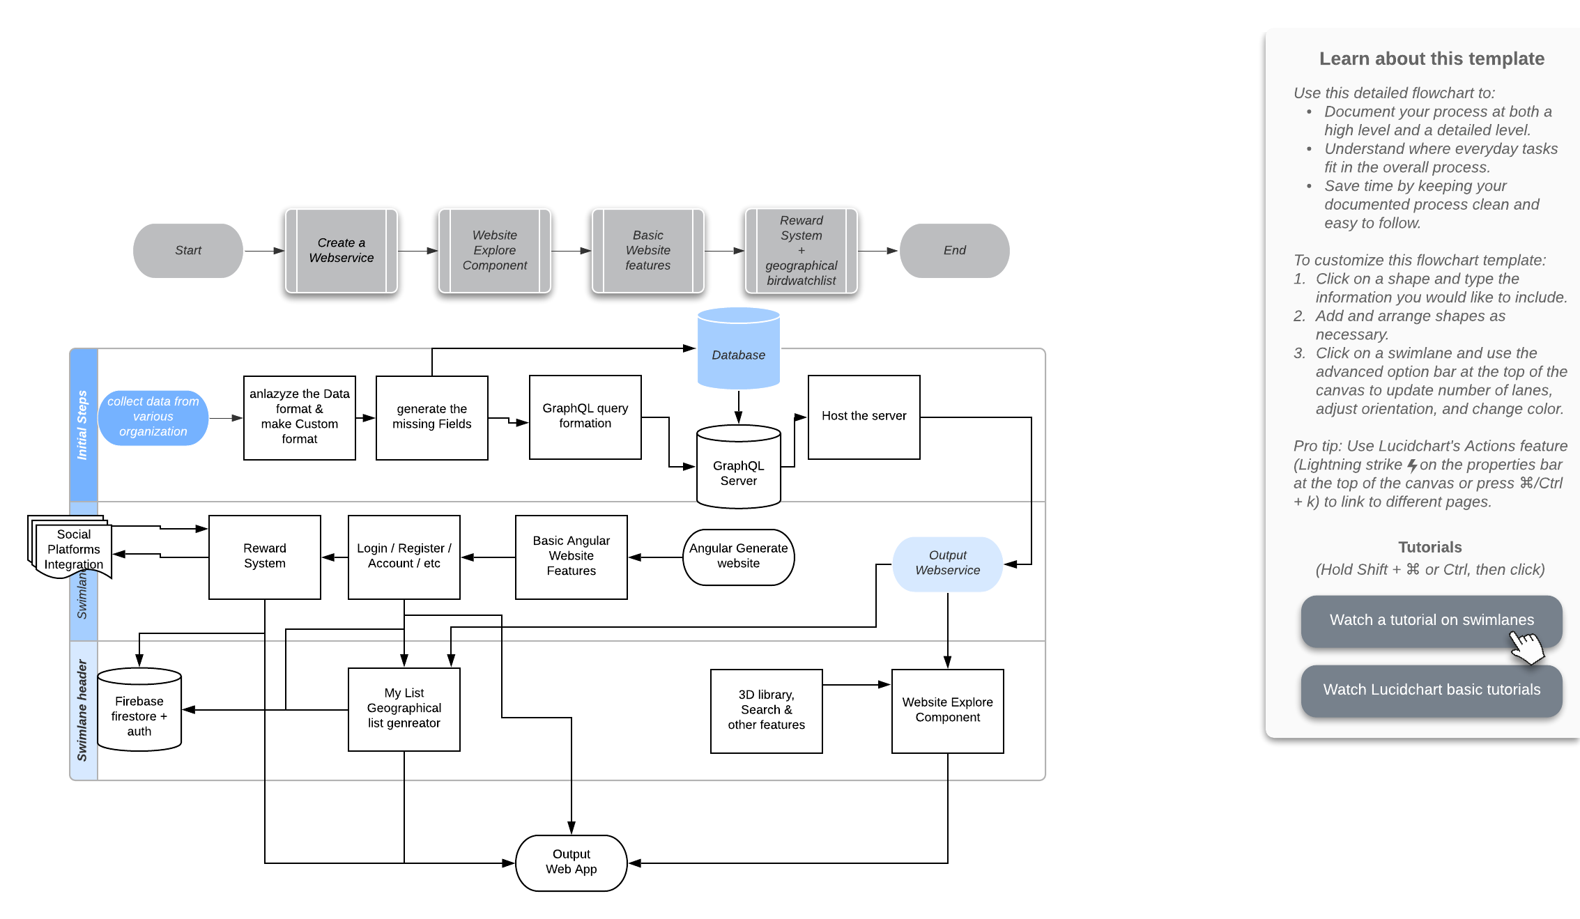
Figure 1.1 – Project Plan

The Implemention of the project currently depends on independent services they are as follow
- Web Service
- Web Hosting
- Database
- Authentication
- Web App

Chapter – 2

Design Analysis & Methodology

Implementation Strategy

3.1 AEIOU Summary -

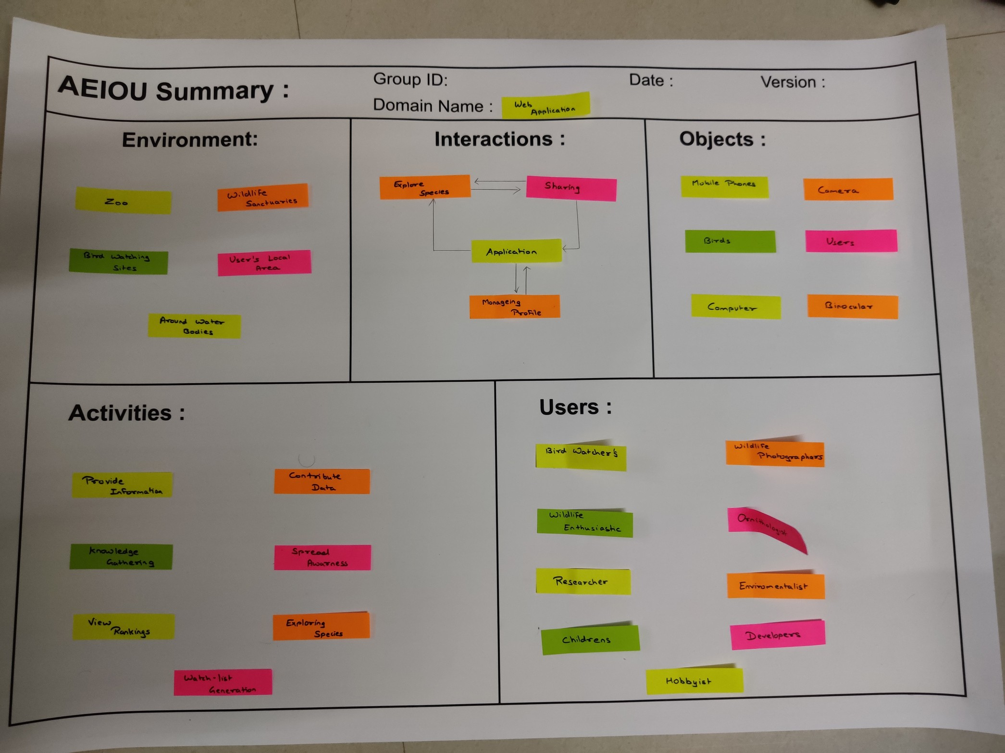
Figure 2.1 – AEIOU Summary Canvas
AEIOU activity expands thinking in perspective to every Activities, Environment, Interaction, Objects and Users, from which we are able to make this summary which includes the situations and the factors responsible for them.

3.2 Empathy Mapping Canvas -

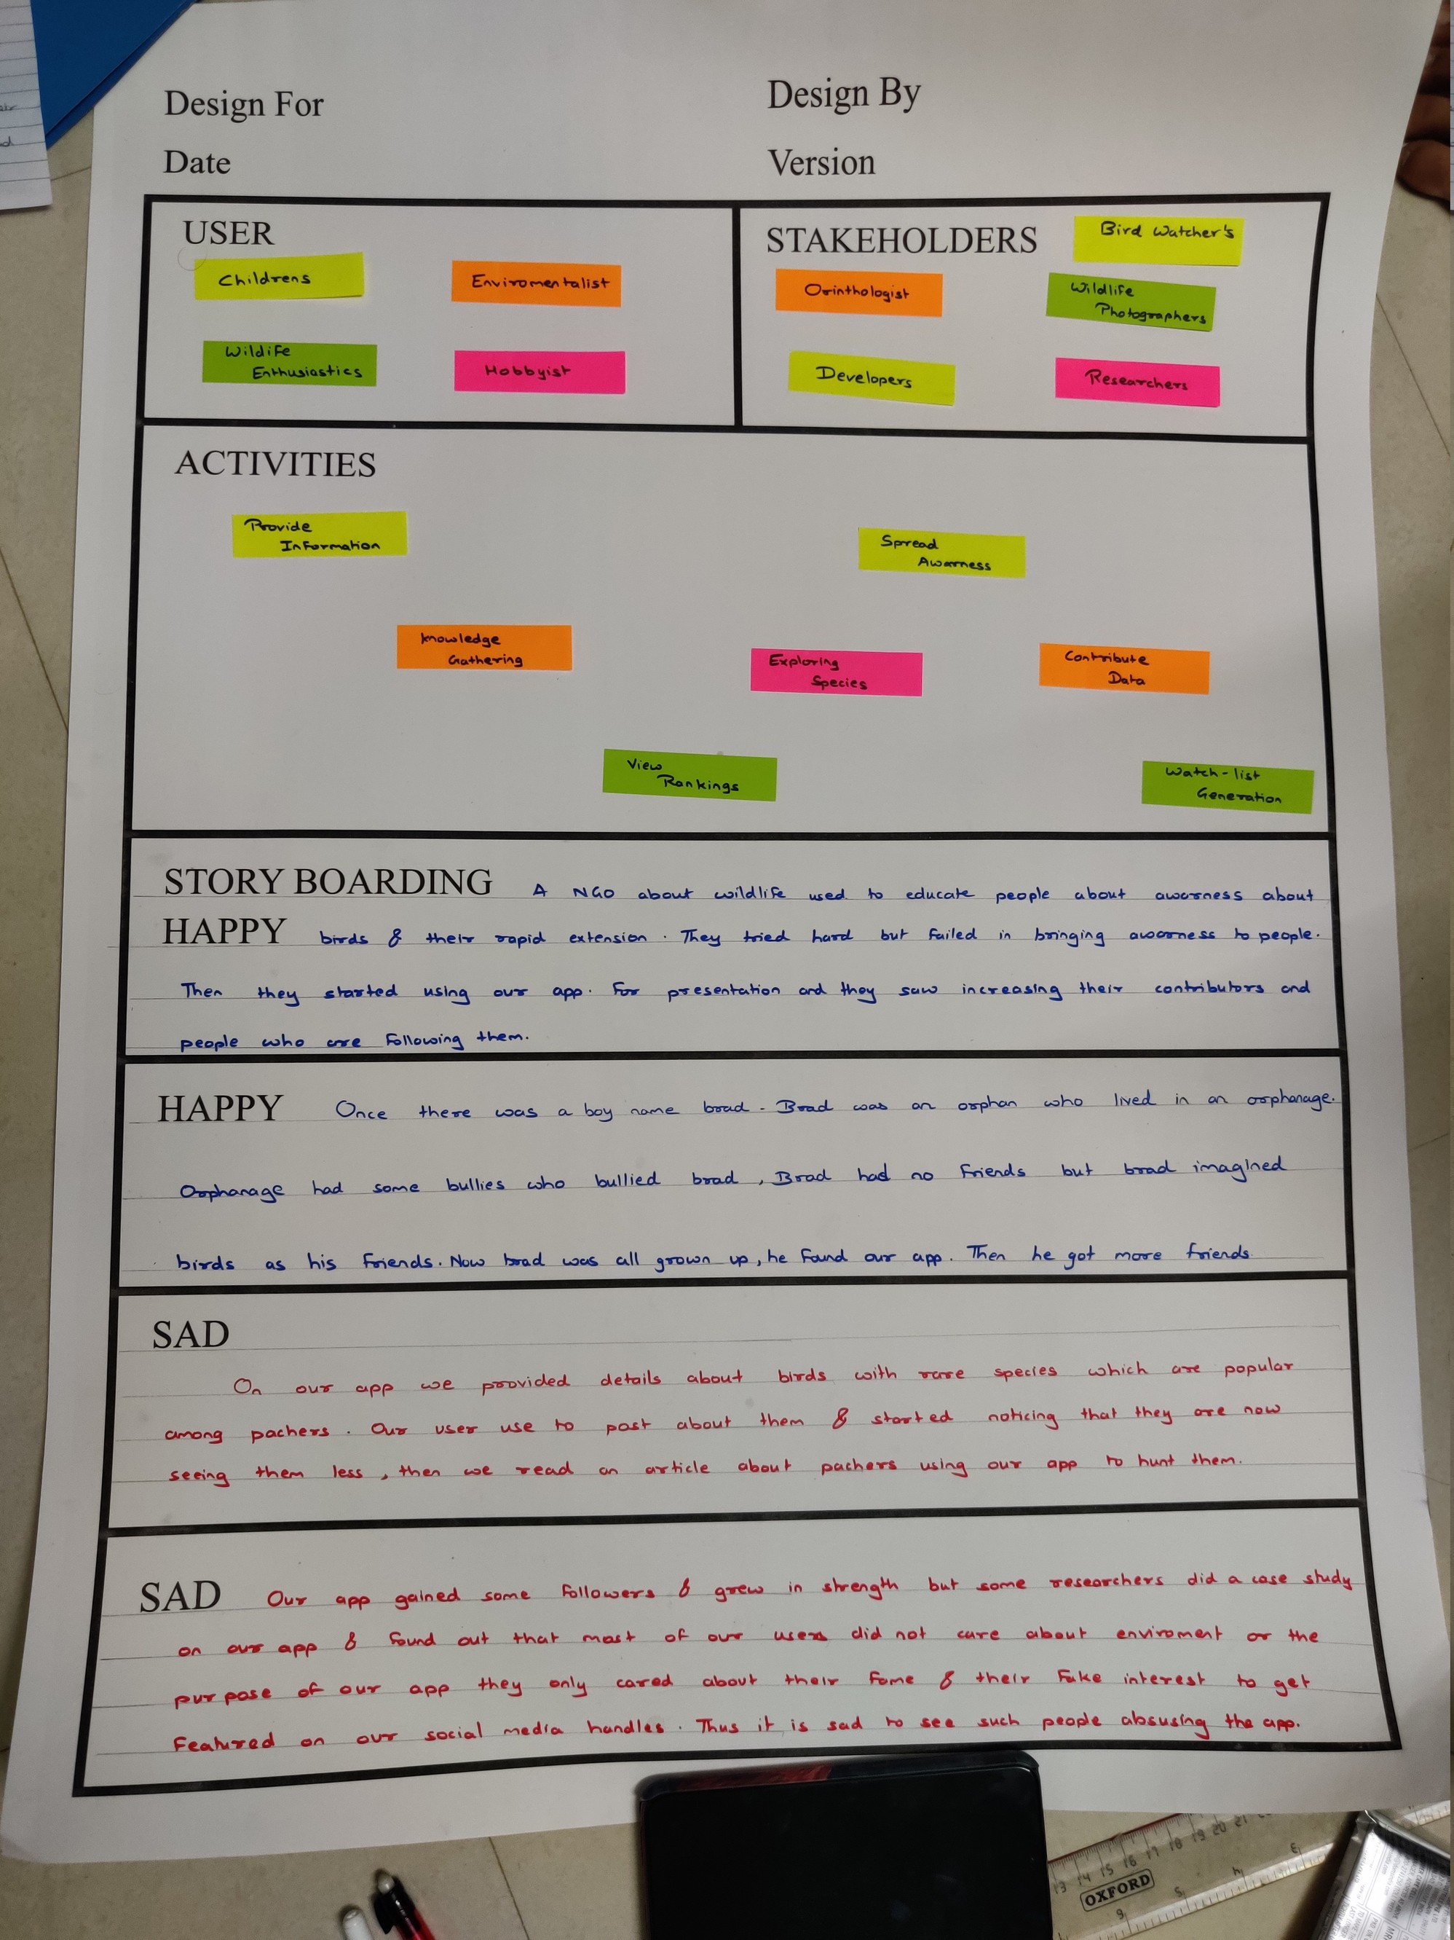
Figure 2.2 – Empathy Mapping Canvas
Empathy Mapping Canvas gives us insights to the mindset of various peoples and identifies who will benefit directly and who will benefit from other means due to activity of some people, it also includes short stories which depict some scenarios of the product. Scenarios are best showcased using two happy and two sad stories.

3.3 – Ideation Canvas -

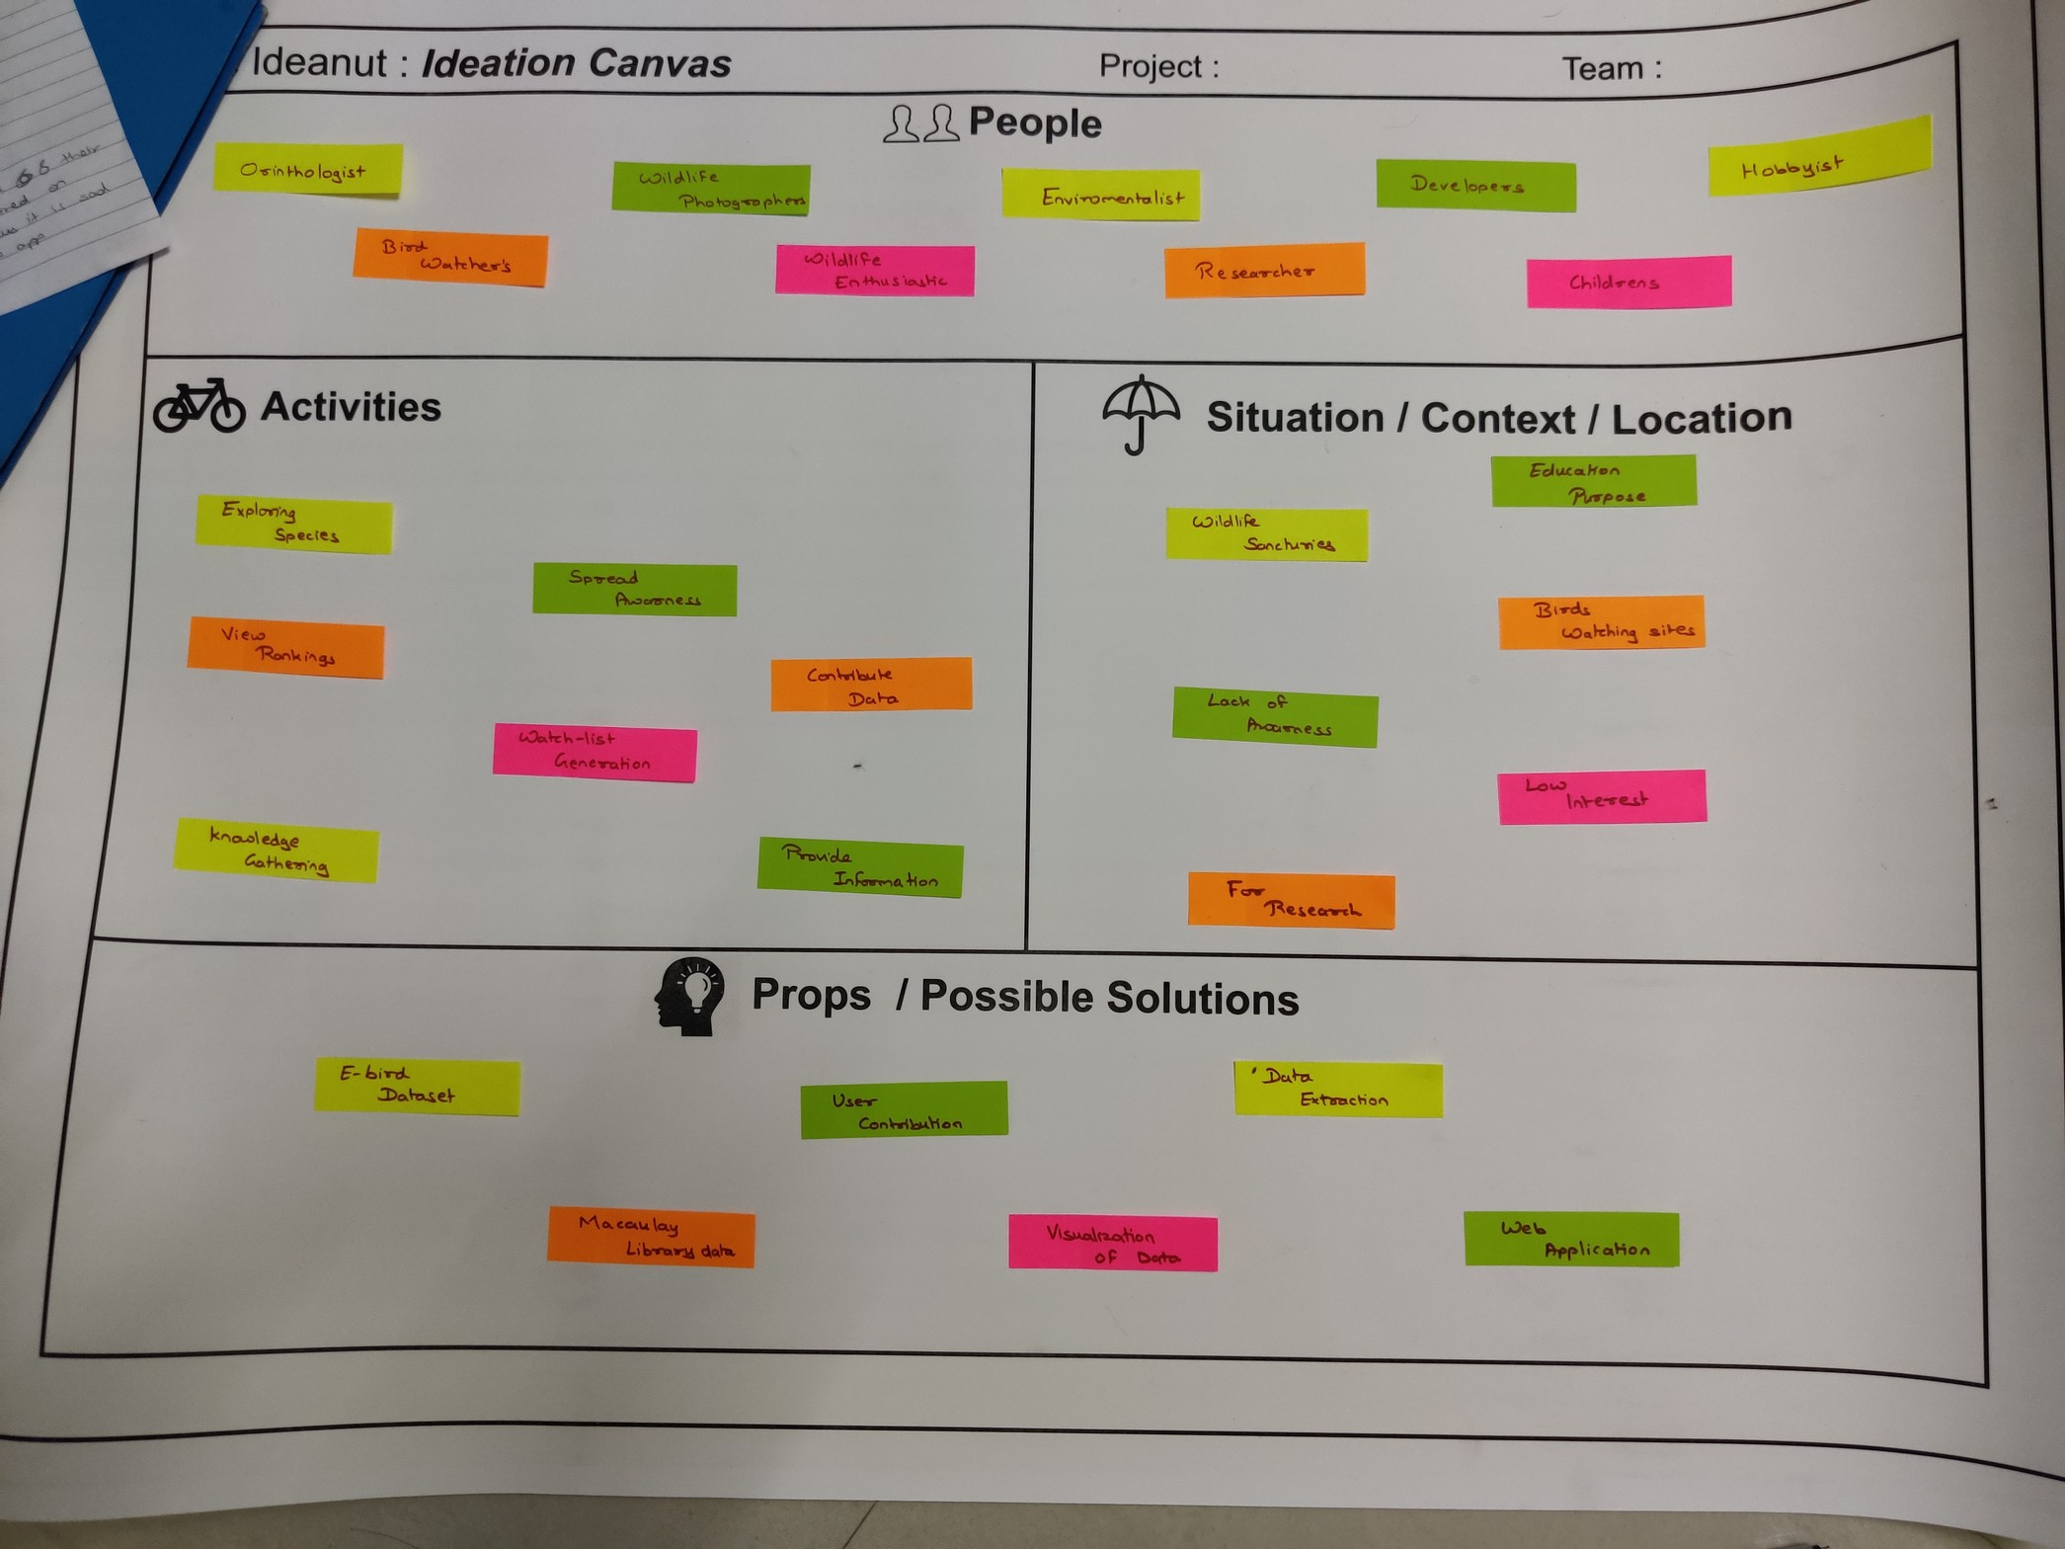
Figure 2.3 – Ideation Canvas

Based on the observation in the previous AEIOU summary a particular Ideation can be derived which results in the Ideation Canvas above. This canvas shows the initial idea about the formation of the product and shows how a particular product should be designed. The factors that will be affecting the development of the product are also included in this canvas.

3.4 Product Development Canvas -

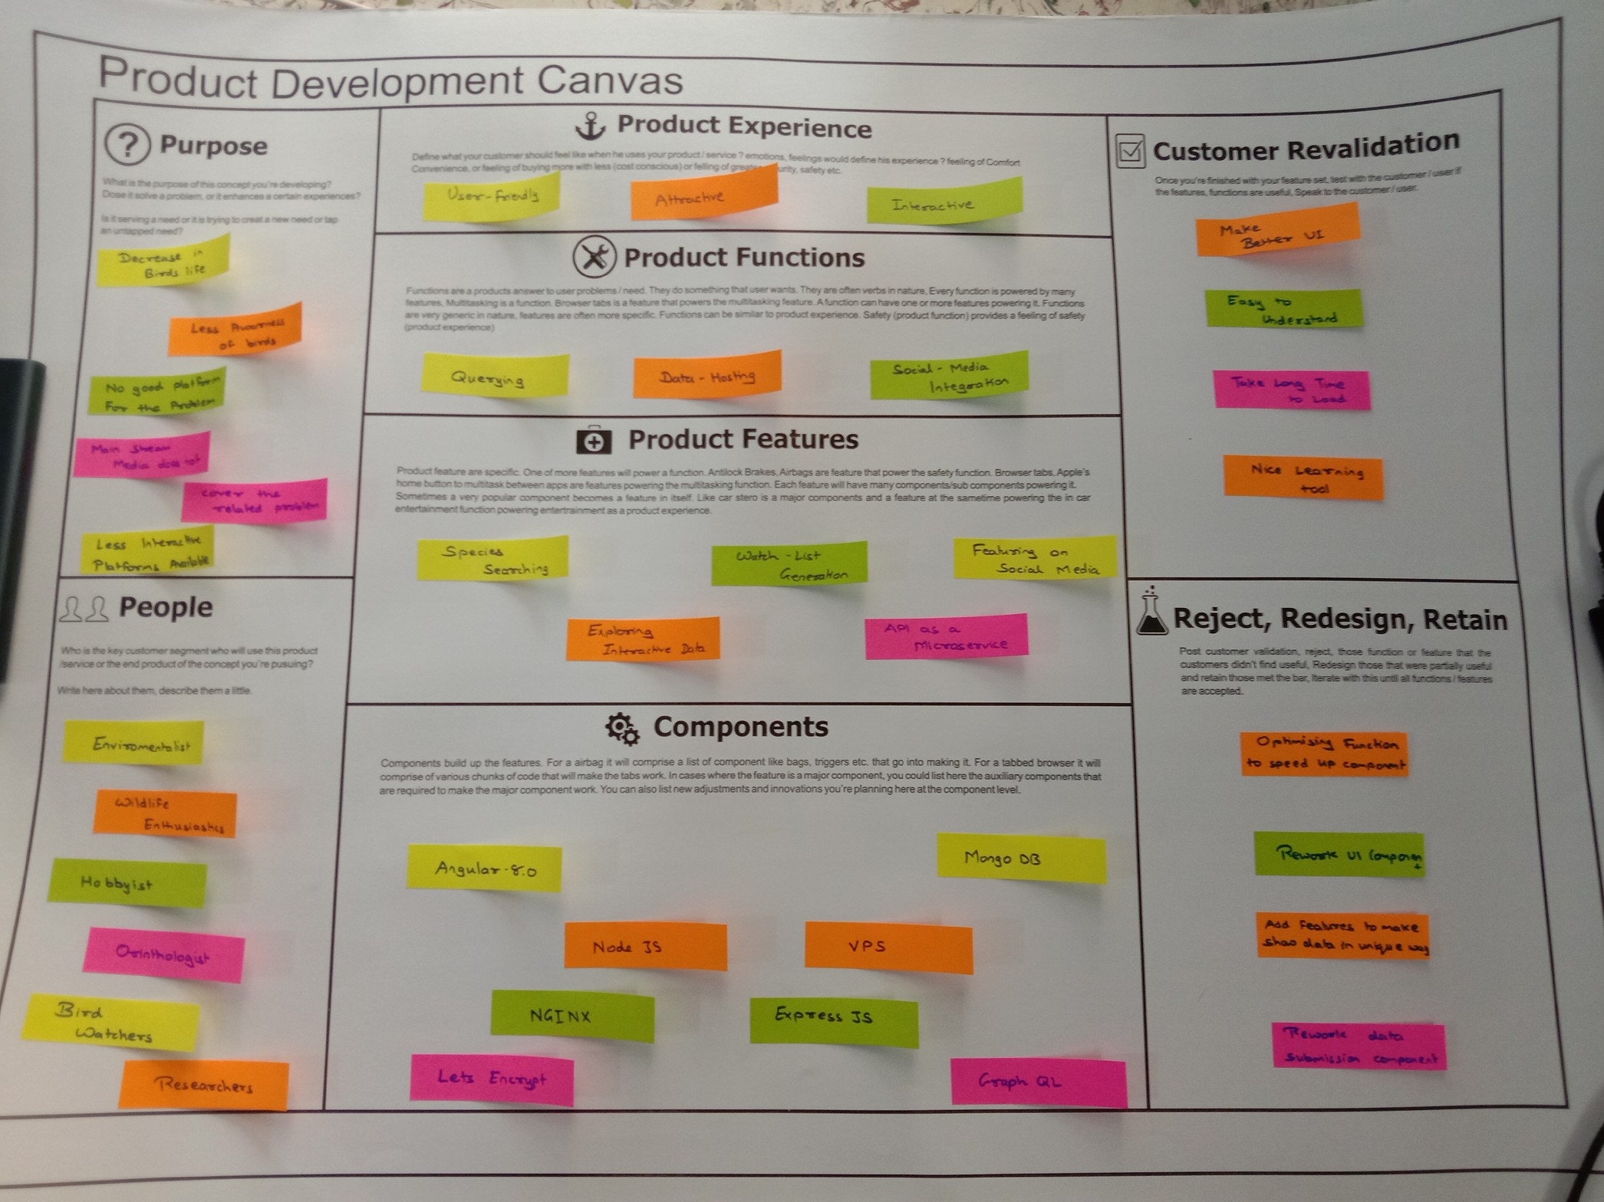
Figure 2.4 – Product Development Canvas

The ideation stage of the product and going through the empathy part of the product it is time to design the final product definition, users, features, functions and components. This canvas will let us know exactly the amount of efforts and the clear idea that is to be put into this project.
After that, the Customer revalidation shows us how true we were in idealizing and creating a solution for the user, then according to the Validations it is up to us that we reject, redesign and retain the function and features according to the feedback from the customer.

Chapter – 3

Project Implementation

The Implemention of the project depends on independent services they are as follow
- Web Service
- Web Hosting
- Database
- Authentication
- Web App

These can further be divided into their own categories and components based on the required feature
these goals are classified as follows
- Back End
  - Web Service
  - Web Hosting
  - Database Hosting
  - Authentication
- Front End
  - Web Application
  - UI and UX
  - WebGL based 3D Map based environment

3.1 Web Service – API

Web service will provide data from database of birds metadata and data that is required for the project and collected from various sources or being referenced from other sources to the user.

To Implement this we will be using GraphQL a query language for APIs and a runtime for fulfilling those queries with your existing data. GraphQL provides a complete and understandable description of the data in your API, gives clients the power to ask for exactly what they need and nothing more, makes it easier to evolve APIs over time, and enables powerful developer tools.

This Service will be used by the application to get data for the web app and the required data will be provided to the webapp to display, using this we can combine data from various different projects that related to ours and have collected data for years to be used in this project.

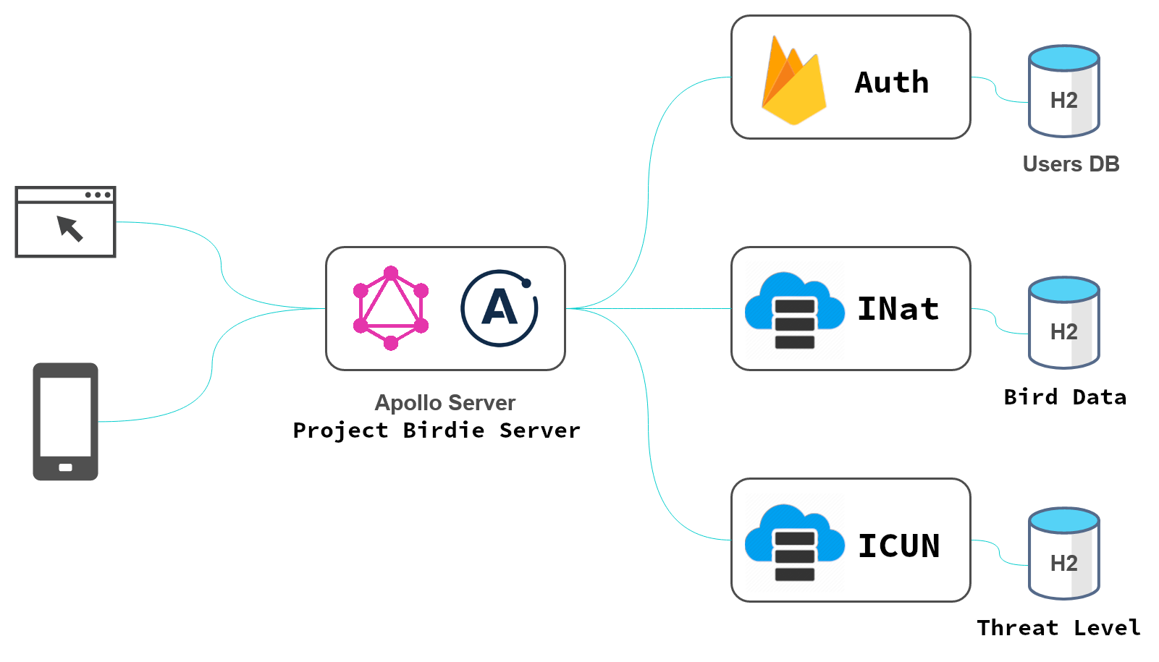
Figure 3.1 – GraphQL Architecture

The Above mention figure is referenced form wrapping a REST API in GraphQL, here we will combine the backend service to get output from a one destination that a user will query into and the GraphQL will handle method to output data to the user.

3.2 Web Hosting – Static Site

To Serve the users our application we need a service to host out application i.e. server, web app. To fulfil this purpose we will use a VPS service where we can serve the application from VPS stands for Virtual Private Server.

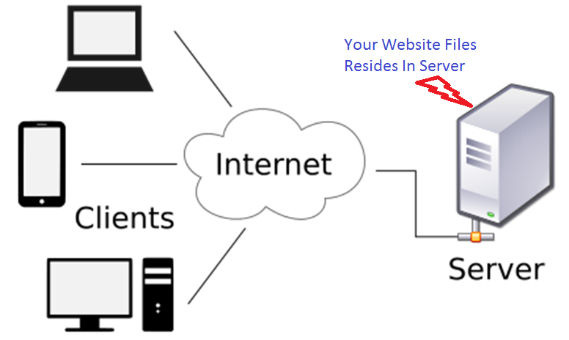
Figure 3.2 – VPS Architecture
VPS provides control over how the application will run and encryption protocols used to serve data to the user a VPS is a paid service where we can run a private machine in an data center of the providing organization and a IP address to the VPS that can be found on the internet and used to serve the application.
For the server we are using Node.js to serve the data by means of GraphQL on VPS we will use Node.js to serve the application to user using Express.js a backend library for developing server in a Node.js environment.

3.3 Database Hosting – MongoDB

Database is an important part of any application as it collects data from user and application to be used into application.
We have to host data for our application which we has been sourced from various organization and we have used in our app for efficient quering purposes, but it’s in form of archived data i.e. millions of records that are not categorized for our needs so we need a service which is flexible in handling data and be merged together without hassle of making SQL relations therefore we will use MongoDB as Database Solution as its effective in handling different field of entries which can be dynamic and easily queried.

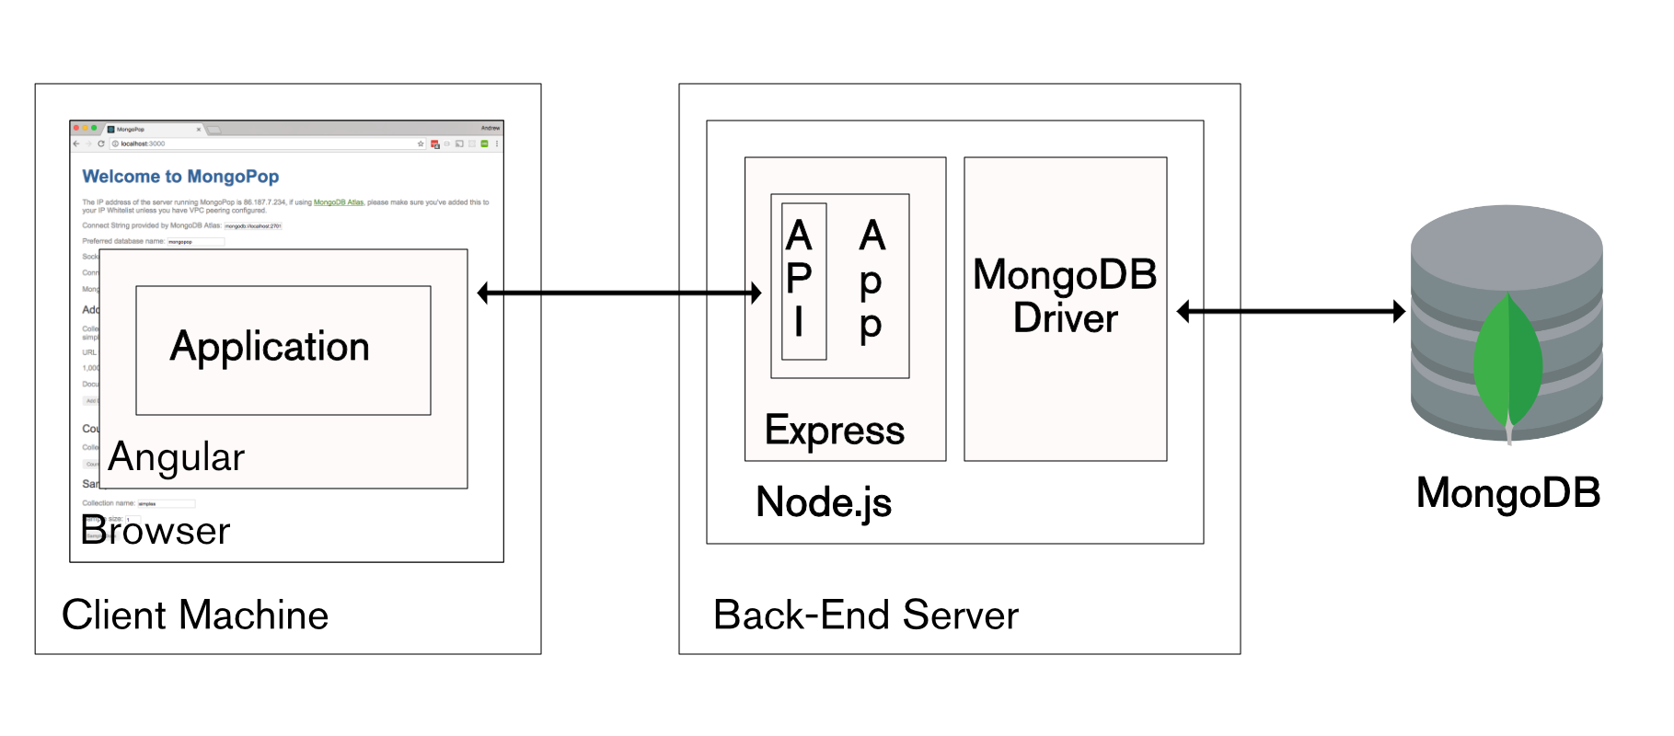
Figure 3.3 – MongoDB Architecture
Note - The Database will be hosted on the same VPS as mentioned above.

3.4 Authentication

For authentication purpose we will use Firebase from Google as a solution due it being service from a large company and can be used for free as we are only going to store data related to user which is sensitive and have to be kept secure, doing custom implementation of such feature may provide some security vulnerability.

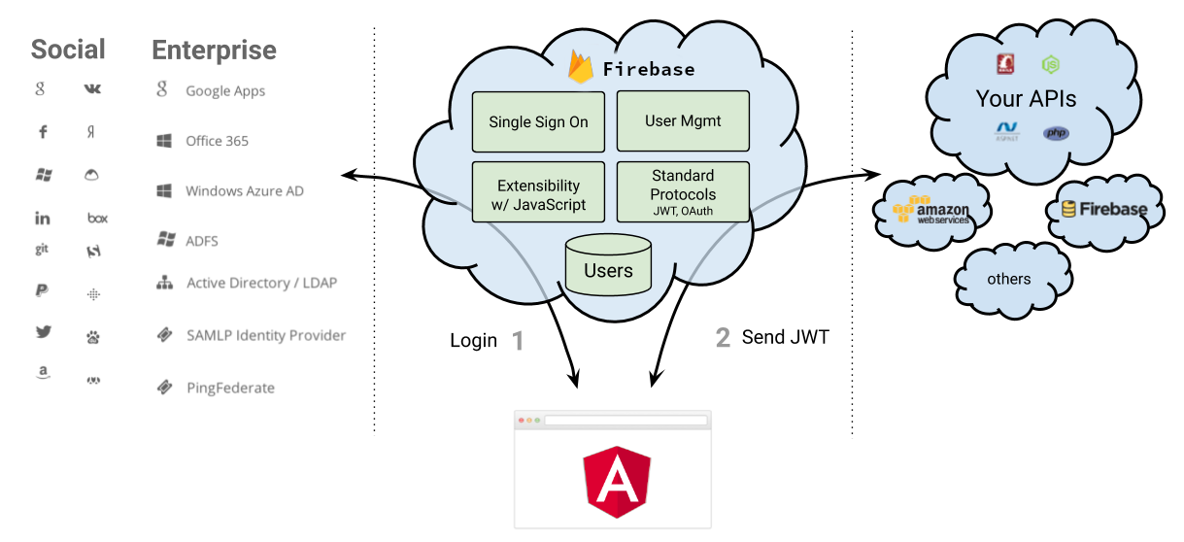
Figure 3.4 – Firebase Architecture

Firebase provide secure authentication services, validation, and other services which are crucial to the application thus providing an abstraction in such features and services, It also provides with Oauth function service which is standard for sharing user credentials of a already established webapps like google, facebook, twitter, github, & etc., would also be provided.

3.5 Web App – project birdie website

Angular is an application design framework and development platform for creating efficient and sophisticated single-page apps, our application is a WebGL based project with requires a very complex interactive UI elements which need to react to changes in a canvas rendered and from UI to canvas to streamline this process of communication we decided to use it for our applications.

Angular framework has set of all tools and methods to make our application smooth as possible with getting data from server, communicating changes back and fourth to Explore Component and UI which are coupled with help of services from angular, the core features of angular can be classified as follows

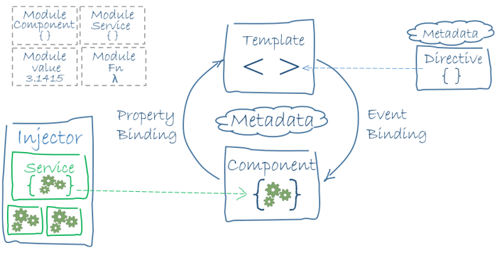
Figure 3.5 – Angular Architecture
Our project consist of Module level separations i.e.
- Authentication Module
- Core Module
- Contribute Moudle
- Explore Module
- Shared Module
- Watchlist Module

Each Module may consist of various modules type of components in our web app like core module contains components related to core website i.e. header, footer, navigation, etc., and much more explained further.

Service are essential part of the webapp as they couple the modules with each other by providing data required to it and components of module react to changes in the data provided by the services, classification of services is done in following manner
- Engine Service – Will manage the rendering of the canvas and all the methods related to 3D Rendering.
- Explore Service – has all methods and data to manipulate canvas from UI Components.

- Auth Service – This will handle all the necessary data to authenticate user from firebase and keep his session maintained.
- Data Service – This will get the data from the backend API and send data to it when deemed necessary.
- Data Bus – the service which will be used to manipulate UI components.

Using Angular we can modularize the code into components so that they are easy to implement and handle in the application.

Authentication Module – Includes

- Login Component
- Register Component
- Forgot Component
- Verify Component
- Auth Service
- ValidEmail Directive
- ValidPassword Directive

Core Module – Includes

- Header Component
- Navigation Component
- Footer Component
- Profile Component
- DataBus Service
- And many more ease of use Directives

Contribute Module – Includes

- Observation Component
- Article Component

Explore Module – Includes

- Explore Component
- Ave Component
- Observation Component
- Search Component
- User Component
- InfoPanel Component
- Explore Service
- Engine Service
- Ease of use Directives

Shared Module – Includes third party Components, Directives.

Watch List Module – Includes

- Bird Component
- Gallery Component
- List Component
- Info Panel Component

3.6 Reward System

This is a manually manged accounts on twitter and instagram which will be showcasing prominent photos taken by the users and featuring them on page.

Chapter – 4

Summary and Mockups

4.1 – Implementation

❖ Authentication Module
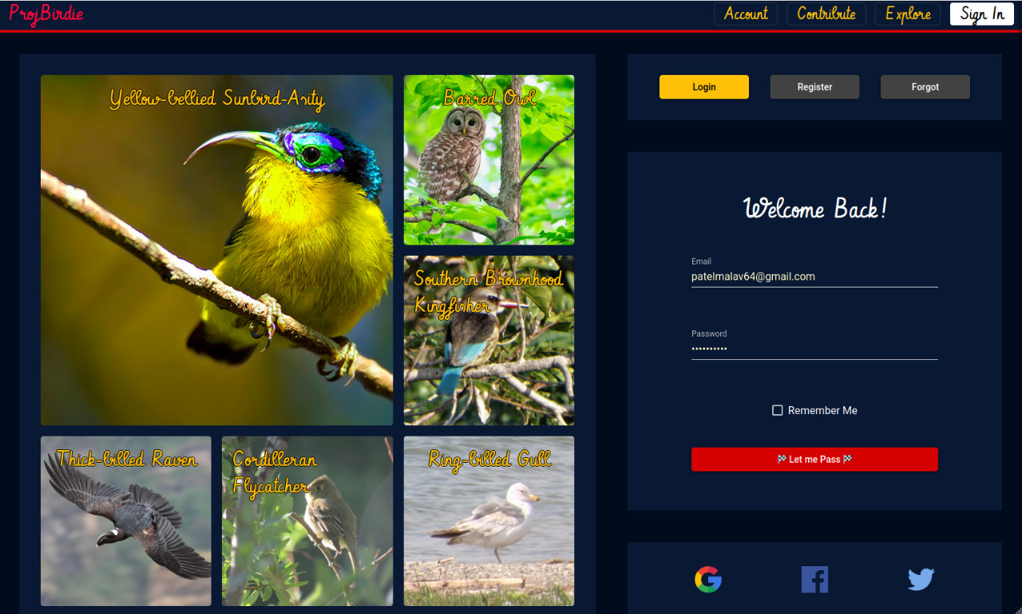
Figure 4.1 – Authentication overview
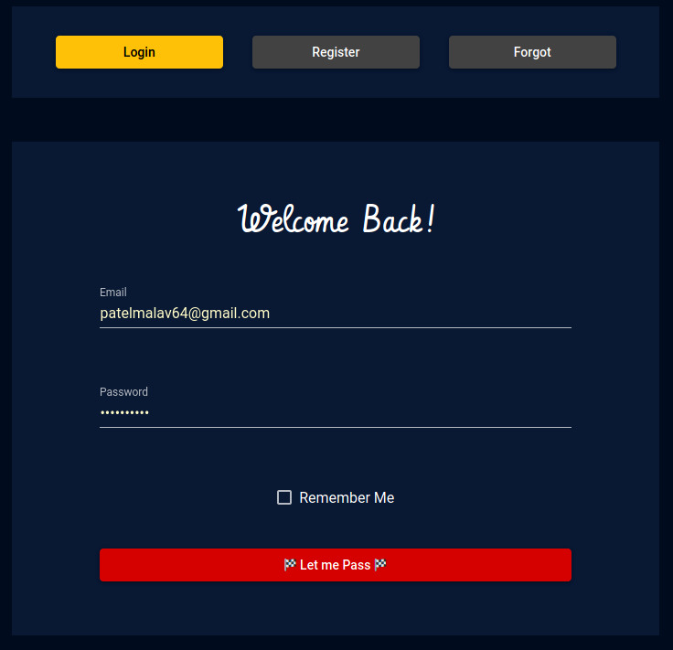
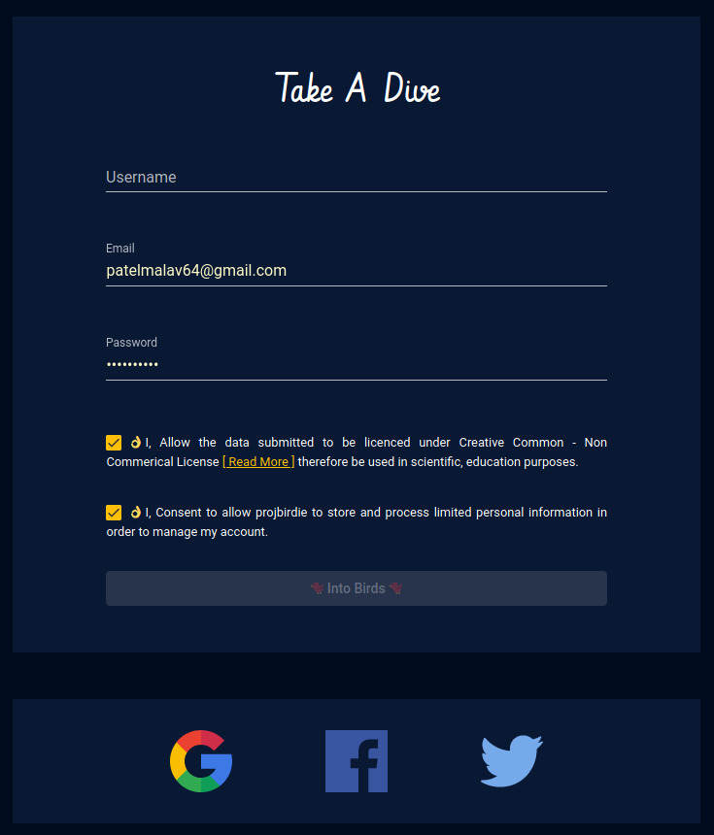

Figure 4.2 – Login Component Figure 4.3 – Register

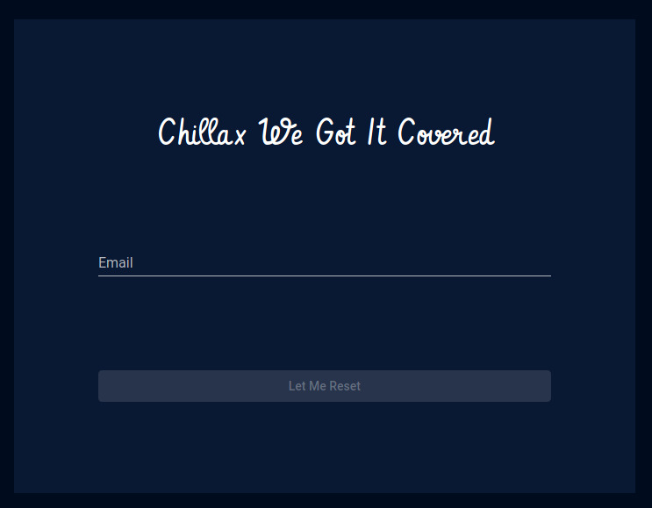
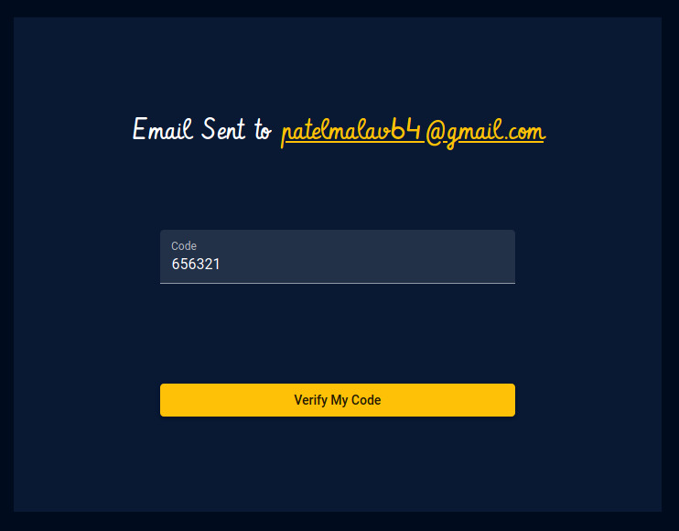

Figure 4.4 – Forgot Figure 4.5 – Verify

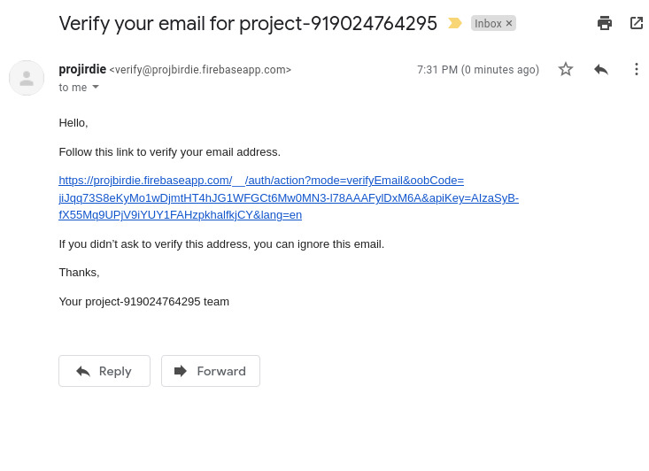

Figure 4.6 – Email verify

❖ Explore Module
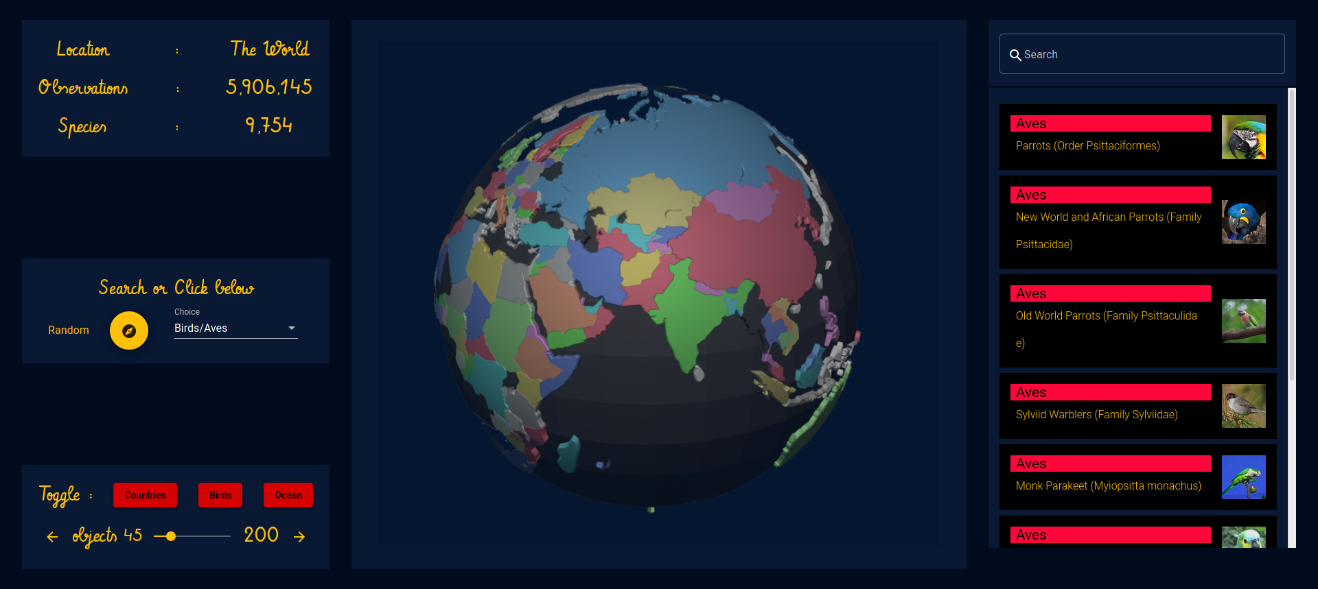
Figure 4.7 – Explore overview

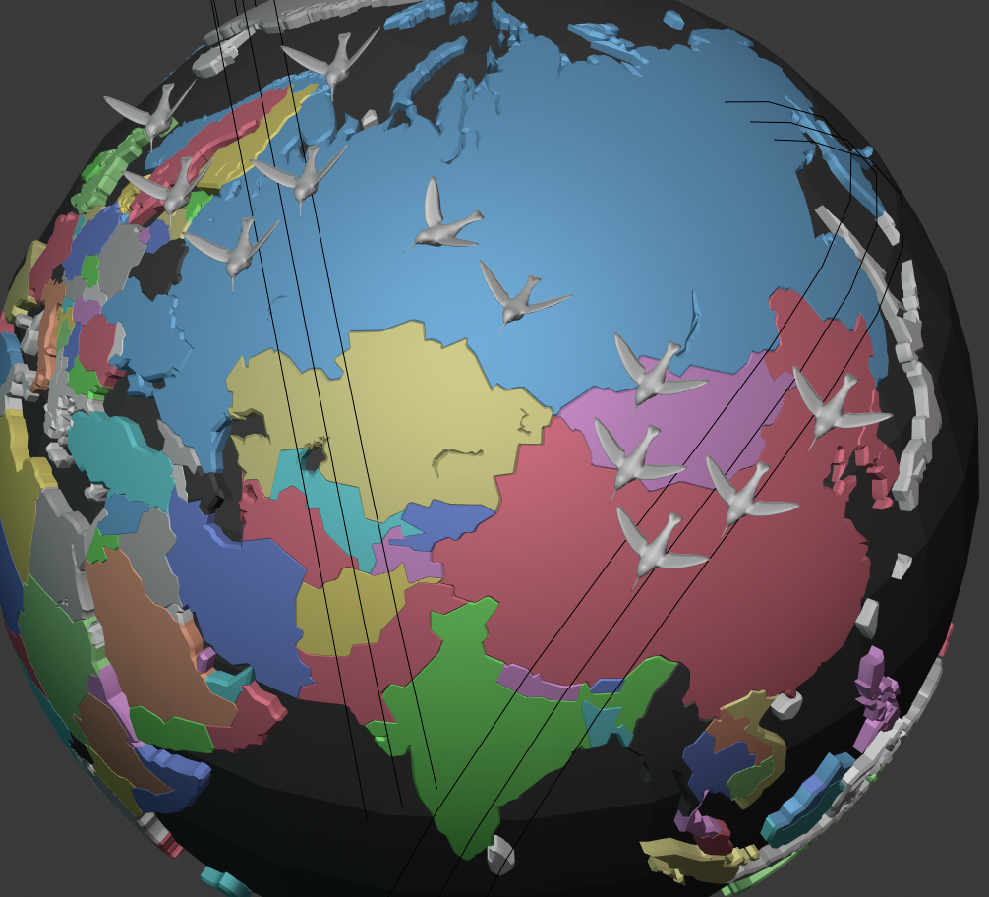

Figure 4.8 – Aves Component



Figure 4.9 – Aves Component

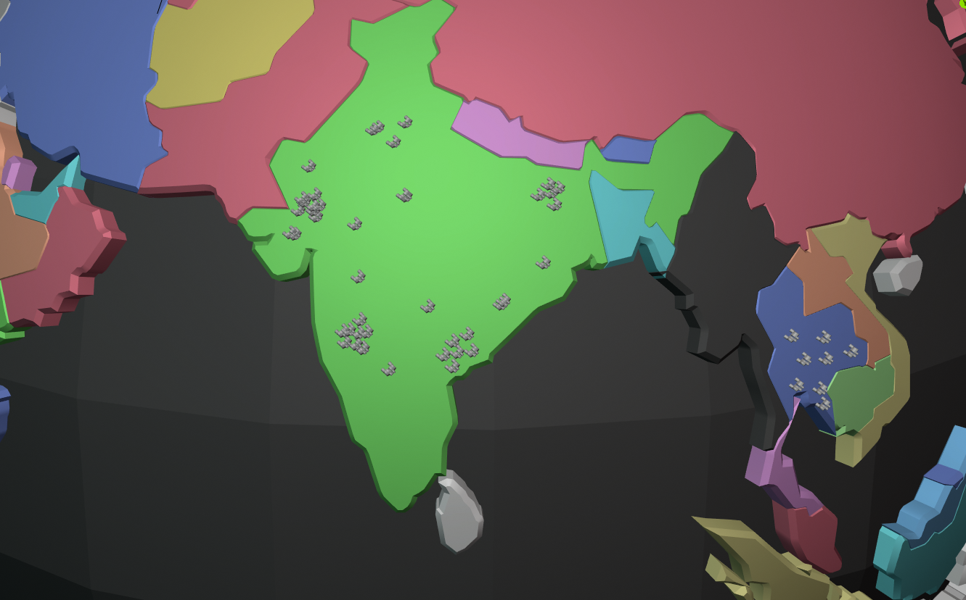

Figure 4.10 – Observations Component

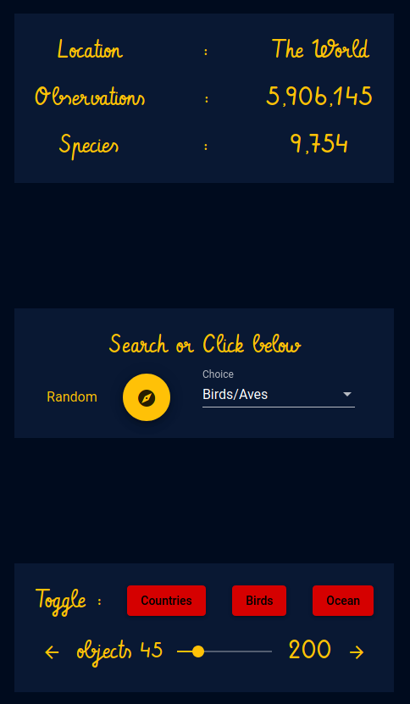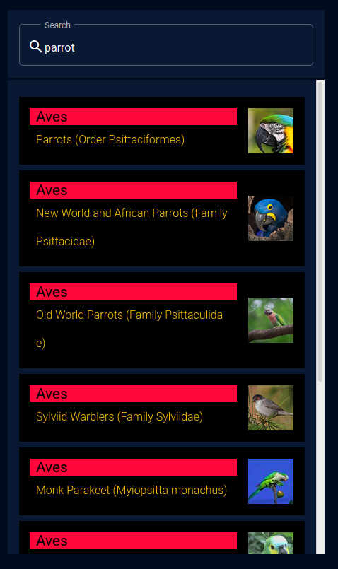

Figure 4.11 Interactive Controls Firgure 4.12 Search Component
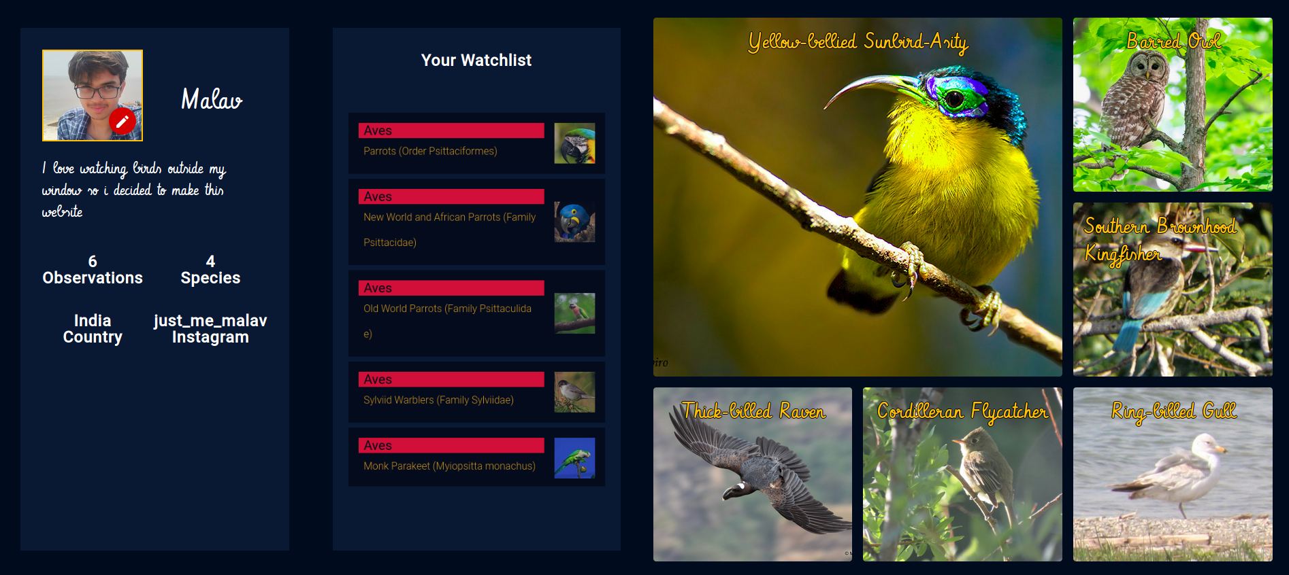

Figure 4.13 – Accouunt Overview

4.2 – Summary

- The application can be used by people to visualize the data about birds in a 3d interactive manner, where users can search for following terms
  - Aves – any bird whose identification has some scientific knowledge and a depth associated
  - Observation – all the past observations contributed on the Inaturalist Network and the user submission on the app.
  - Users – any verified users whose profile is public on Inaturalist Network and users of app.
- Users can register for the application and generate a watchlist that is tailored to their nearby species of birds present.
- Users can contribute to the app with their sightings.
- Users can see articles submitted and upload one.

4.3 – Future Scope

- Explore component to be more precise to a level of state or county, currently at a level of a country.
- Share user submission with a share button.
- More Interactive elements such as select a country from canvas, select an observation from canvas.
- Less Convoluted Wikipedia content.
- Better search results.

Chapter – 5

Project References

Sr. No. | Name | URL
 | National Georaphic | www.nationalgeographic.com
 | Ebird | https://ebird.org
 | iNaturalist | https://www.inaturalist.org
 | GraphQL | https://graphql.org/
 | Article – GraphQL | https://medium.com/@joeynimu/wrapping-a-rest-api-in-graphql- f50c7b9669d5
 | Node.js | https://nodejs.org/en/
 | Express.js | https://expressjs.com/
 | MongoDB | https://www.mongodb.com/
 | Angular | https://angular.io/
 | Angular Material | https://material.angular.io/

Chapter – 6

Appendix

6.1 – Periodic Progress Reports (PPR)

Periodic Progress Report – 1 (PPR – 1)
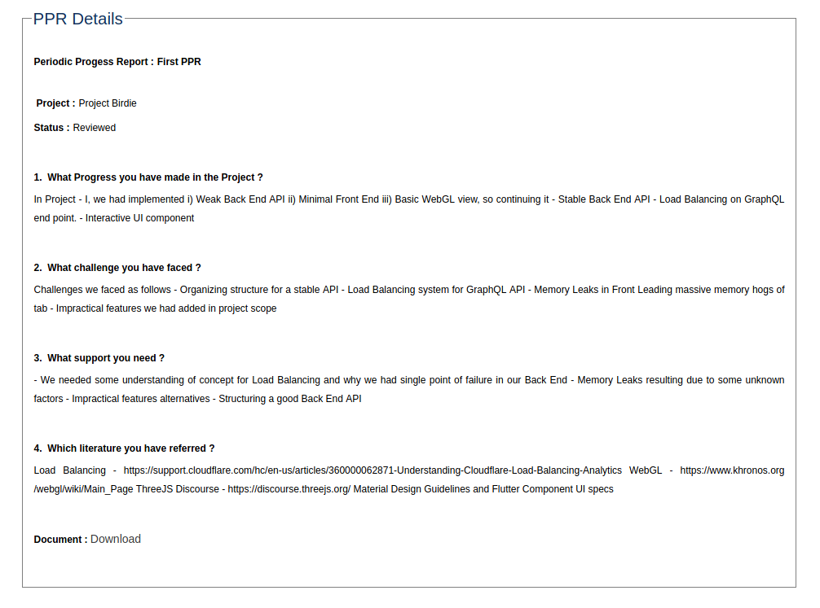
Figure 6.1 – PPR - 1

Periodic Progress Report – 2 (PPR – 2)
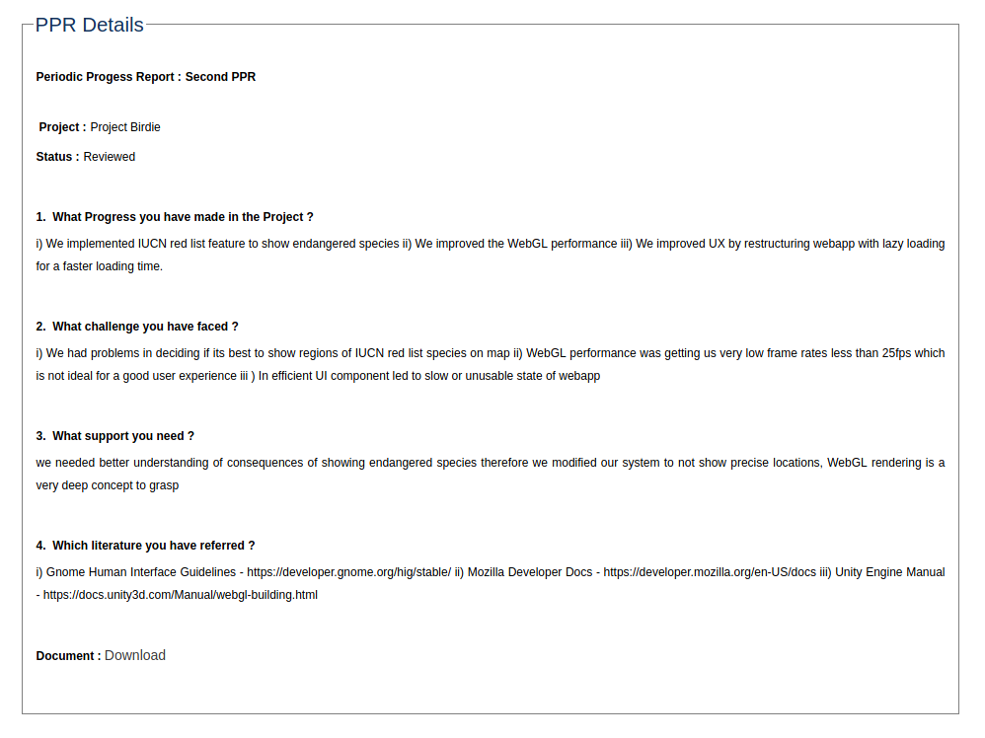
Figure 6.2 – PPR - 2
Periodic Progress Report – 3 (PPR – 3)
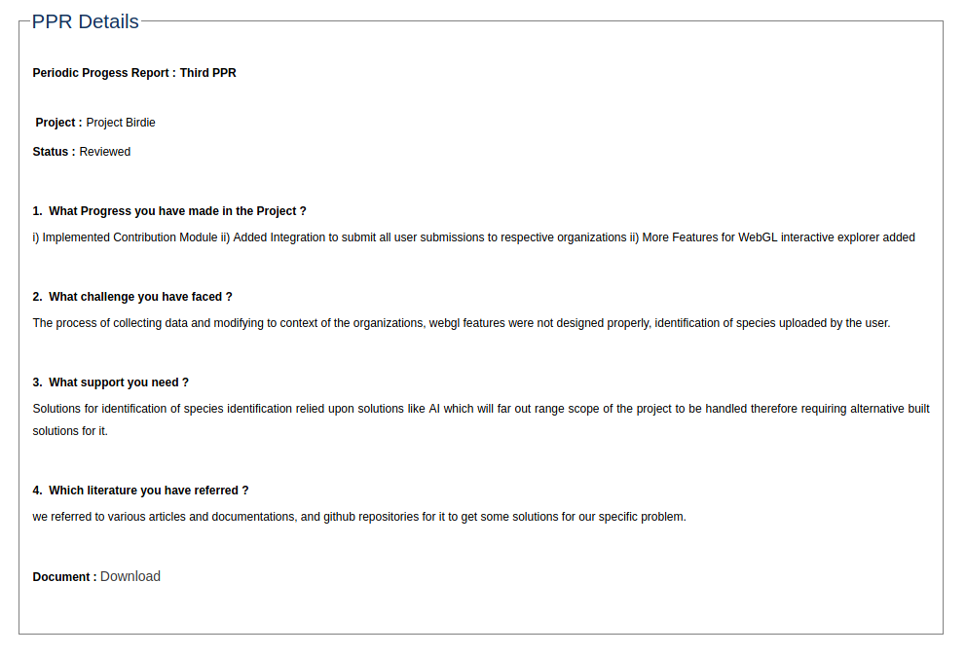
Figure 6.3 – PPR - 3

Periodic Progress Report – 4 (PPR – 4)
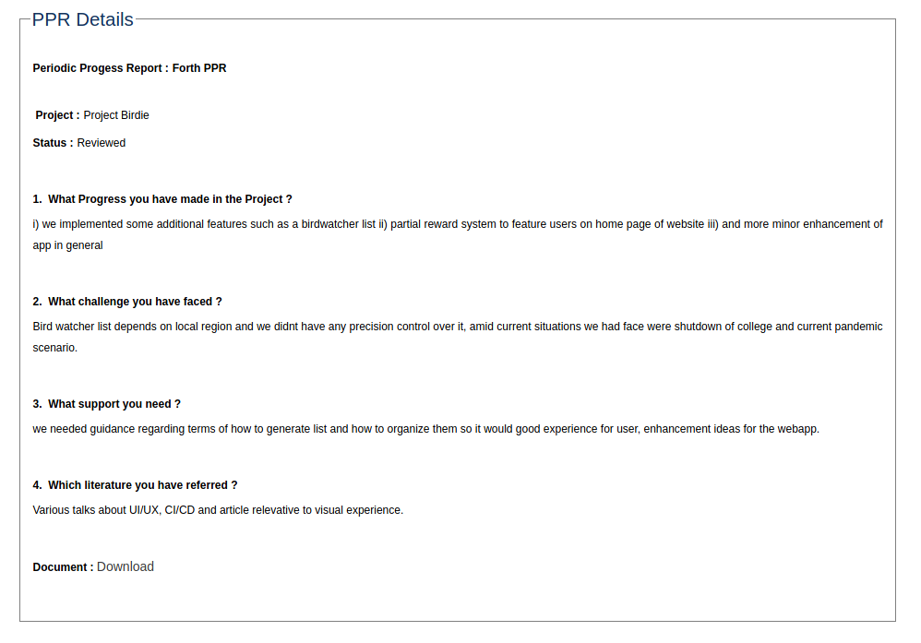
Figure 6.4 – PPR – 4

6.2 – Business Model Canvas (BMC)

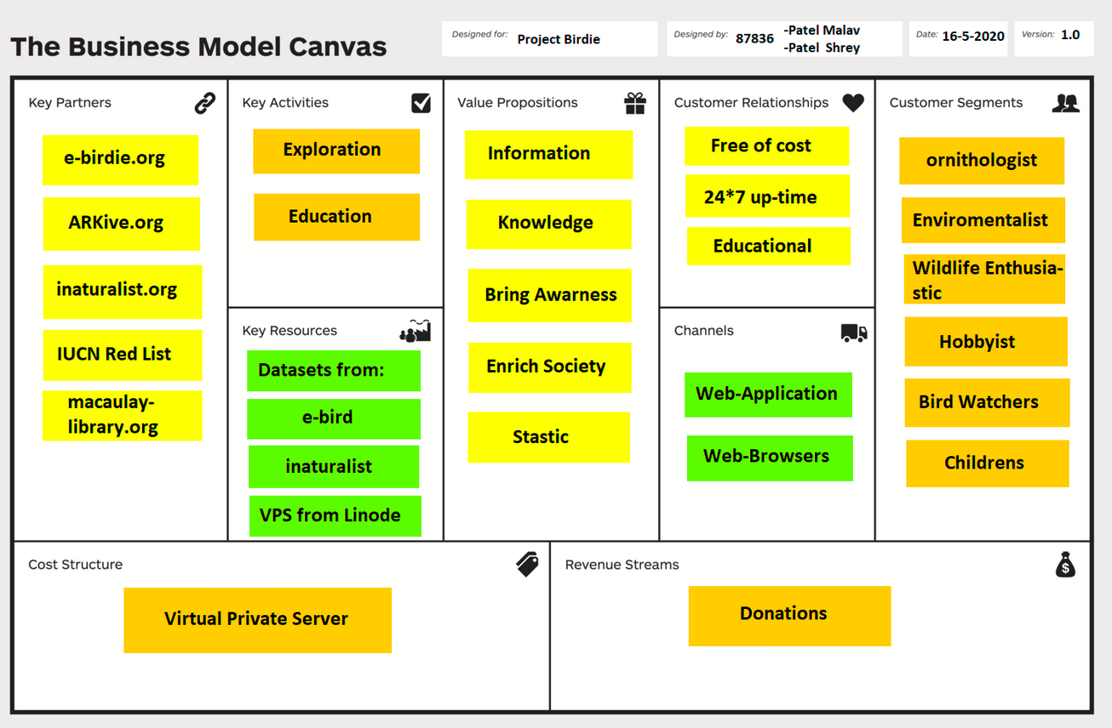
Figure 6.5 – BMC Canvas

1. Introduction

The business model canvas (BMC) is a great tool to help you understand a business model in a straightforward, structured way. The BMC is a shared language for describing, visualizing, assessing and changing business models. It describes the rationale of how an organization creates, delivers and captures value. Using this canvas will lead to insights about the customers you serve, what value propositions are offered through what channels, and how your company makes money. It is useful to understand your own business model or that of a competitor!

2. Key Partners

Key Partners are the relationships that you have with other business, governmental, or non- consumer entities that help your business model work. These can be the relationships that your company has with your suppliers, your manufacturers, business partners, etc. These partnerships that you will undoubtedly create will be forces that help your business succeed in areas that would be inefficient for you to do yourself. Key Partners of Our Project are given below:
- E-birdie.org
- ARKive.org
- Inaturalist.org
- IUCN Red List
- Macaulaylibrary.org

3. Key Activities

Key activities are any activities that your business is engaged in for the primary purpose of making a profit. Business activities include operations, marketing, production, problem-solving, and administration. What do you do every day to run your business model?
- Exploration
- Education

4. Key Resources

Key Resources describes the most important assets required to make a business model work. These are the resources that allow an enterprise to create and offer a Value Proposition, reach markets, maintain relationships with Customer Segments, and earn revenues. The people, knowledge, means, and money you need to run your business.
- Datasets from:
- E-birdie
- inaturalist
- VPS from linode

5. Value Propositions

The Business Model Canvas value proposition provides a unique combination of products and services which provide value to the customer by resulting in the solution of a problem the customer is facing or providing value to the customer. This is the point of intersection between the product you make and the reason behind the customer’s impulse to buy it. A product can have a single value proposition or multiple value propositions. What are your products and services? What is the job you get done for your customer?
- Information
- Knowledge
- Bring Awarness
- Enrich Society
- Stastic

6. Customer Relationships

Customer relationships describes the type of relationship a company establishes with its specific customer segments. Customer relationships are driven by customer acquisition, customer retention, a boosting sales – in other words you need to get, keep, and grow your customer relationships. How does this show up and how do you maintain the relationship?
- Free of cost
- 24*7 up-time
- Educational

7. Channels
The Channel Building Block describes how a company communicates with and reaches its Customer Segments to deliver its Value Proposition. It is important to understand which pathway (or channel) is best for your company to reach your customers. How do you communicate with your customer? How do you deliver the value proposition?
- Web Application
- Web Browsers

8. Customer Segments

Customer segments are the community of customers or businesses that you are aiming to sell your product or services to. Customer segments are one of the most important building blocks in the business model canvas for your business, so getting this building block right is key to your success. An organization can choose to target a single group or multiple groups through its products and services. List the top three segments. Look for the segments that provide the most revenue.
- Ornithologist
- Environmentalist
- Wildlife Enthusiastic
- Hobbyist
- Bird Watchers
- Childrens

9. Cost Structure

Cost Structure defines all the costs and expenses that your company will incur while operating your business model. This final step in the process is important, because it will help your team decide whether to pivot or proceed. List your top costs by looking at activities and resources.
- Virtual Private Server

10. Revenue Streams

Revenue Stream is the building block representing the cash (not profit which is revenue minus costs) a company generates from each customer segment. When it comes to choosing revenue streams as part of the overall Business Model Canvas, there are many factors that affect your sources of revenue.
- Donations

6.3 – Patent Drafting Exercise (PDE)

College : G. H. PATEL COLLEGE OF ENGINEERING & TECHNOLOGY, V V NAGAR
Department : Computer Engineering Discipline : BE
Semester : Semester 8 Project Name : Project Birdie Team ID : 87836

Form 1 – APPLICATION FOR GRANT OF PATENT
Applicants :

Sr. No | Name | Nationality | Address | Mobile No. | Email Id
1 | Patel Shreykumar Rakeshbhai | Indian | Computer  Engineering ,  G. H. PATEL COLLEGE OF  ENGINEERING & TECHNOLOGY, V V NAGAR ,  Gujarat  Technologycal University. | 7990067637 | patelshrey887@gmail.com
2 | Patel Malav Prashant | Indian | Computer  Engineering ,  G. H. PATEL COLLEGE OF  ENGINEERING & TECHNOLOGY, V V NAGAR ,  Gujarat  Technological University. | 9624905863 | patelmalav64@gmail.com

Inventors :

Sr. No | Name | Nationality | Address | Mobile No. | Email Id
1 | Patel Shreykumar Rakeshbhai | Indian | Computer  Engineering ,  G. H. PATEL COLLEGE OF  ENGINEERING & TECHNOLOGY, V V NAGAR ,  Gujarat  Technological University. | 7990067637 | patelshrey887@gmail.com
2 | Patel Malav Prashant | Indian | Computer  Engineering ,  G. H. PATEL COLLEGE OF  ENGINEERING & TECHNOLOGY, V V NAGAR ,  Gujarat  Technological University. | 9624905863 | patelmalav64@gmail.com

I/We, the applicant(s) hereby declare(s) that:

Following are the attachments with the applications :

Form 2 - PROVISIONAL/COMPLETE SPECIFICATION
1 . Title of the project/invention :
Project Birdie
2. Preamble to the description :
Provisional

3. Description
a) Field of Project / Invention / Application :
- Environmental Awareness : Educate on real world problem of rapid extension of Birds over last decade
- Data Visualization : Provide interactive way of learning through means of exploration in 3D perspective
- Exploration : Engage user in activity to encourage discovery and take a stand
b) Prior Art / Background of the Project / Invention :
The Real world Problem is Unprecedented decrease in Aviation life due to development of new technologies benefit human life but harming the nature, Less or none awareness of the problem is being educated to human beings and humans tend to ignore such problems as part of their nature due to the education platform and news platform does not really tend to focus on such problem apart from environmental problems like global warming as they are not well known or no effort is given.
There are news and articles about such platform already present but they are not enough to highlight this problem as people want something attractive and interesting thing to get focus, this does not include the things like wildlife channels and the photographers that do exploring to get insights into wildlife but apart from that there is no other means to educate people, i.e. there are news article and static data representing websites, apps and other mediums but they are not interesting enough for people to get redirected to and use such things and are kinda boring.
To make people educate about the problem our project is trying to solve it by means of an interactive application that represents the data to user while being informative and attractive with making user involved in the activity and keeping their interest and engaging them into some social attraction that will help them get educated about the life of birds as well as getting data from them to improve the platform upon.
c) Summary of the Project / Invention :
Researcher have have found that there is an unprecedented decrease in aviation life due use of some modern technologies that make human life comfortable, this is an real world problem that we are facing similar to global warming.
Awareness in this problem is less known to people due to it not being covered extensively by traditional standards like schools and news channels, there are news and articles about it and platform to educated the children about life of birds as well as adults but they are not that interesting as they should be and if they were then problem would have been well covered.
To answer that problem this “Project Birdie” is trying to solve by making an innovative & non traditional standard way of application where the users will be educated to birds and their interesting life as well as bring interest to people, thus making them involved in some activity that is unique which will help further this project as well as people will look into the problem we said above as they are involved in it they tend to find and become aware and educate people about it.

d) Objects of Project / Invention :
- Make a web application that works on browsers supporting WebGL
- The Application needs to be interactive and engaging to users
- Users can perform activity in real world and share their activity to application.
- Serve data received from the users and other project that are used in project to be
used by other developers in their own projects

e) Drawings :
f) Description of Project / Invention : (full detail of project) :
To Educate user about the real world problem an article and news letter does not
make it that user is now aware of the problem the user needs to be educated about birds and their environment to make user involved so he/she can understand the problem in depth and then educate others. To achieve an interactive application the user must be able to explore in depth with various visual interface and feel that he/she can get from the application getting their interest so that they may actual learn and try to remember information, thus maybe making them involved in activity they want to seek out.
Activity is essential part of the application as it will make user actually involved into the world of birds by making them a watch list that they could spot at their nearby location and sharing it to others that they spotted some birds unique to their area and making a contribution to the application as well as for themselves and understanding the real world problem more effectively.

The contributions from the users may not be a good research images and data may not be accurate enough to be used in high level application but it can be used as means for research verification or other application where we want to see some trends.
To provide data from our application we may have to extract information from the minimal data that user provides to be used for some purposes and output the data from the system to any user that may build upon the application implement a API to deliver the data.
The API is not only be going to used for the other to offer data but on also the application front end also, so the API needs to be flexible in getting the required data from the application. Now to bring interest to new users and community that may help the application grow we intend to provide a method to feature a user with good contribution that is done by him / her on various social medias so that more people can engage in the activity.
g) Examples :
h) Claims (Not required for Provisional Application) / Unique Features of Project
- 3D visualization of data collected by various organization
- Interactive explorer to discover birds
- Contribute to all leading organization with data submitted by users
4. Claims
5. Date and signature
6. Abstract of the project / invention :
“Project Birdie” is an web application that will be an interactive and attractive platform for educating people about the birds and provide insights to them and start people in engaging in the activty that can be used to benefit environment as well as users.

Form 3 – STATEMENT AND UNDERTAKING UNDER SECTION 8
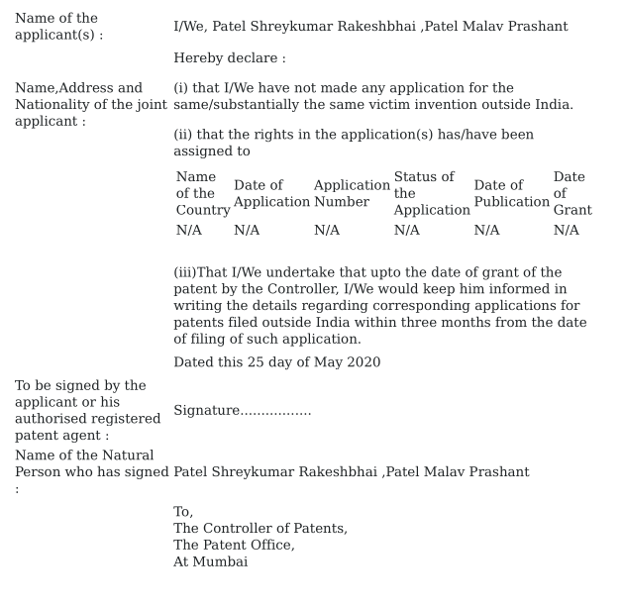

Chapter – 7

Plagiarism Report



